## A PROJECT REPORT

Submitted To



## KITs College of Engineering (Autonomous), Kolhapur

**DEPARTMENT OF COMPUTER SCIENCE AND ENGINEERING**

Project Topic

# Home Interior Design Simulator in VR

Submitted By

|  |  |  |
| --- | --- | --- |
| 1. **Vishwajit Vijay Patil** | **15** | **(1920000248)** |
| 2. **Utkarsh Santosh Ladge** | **44** | **(1920000436)** |
| 3. **Abhishek Dattatray Killedar** | **52** | **(1920000599)** |
| 4. **Asim Sallauddin Mulla** | **61** | **(1920000769)** |

Under the guidance of

### Mr. Sandip Rabade

Department of Computer Science and Engineering

### Academic Year: 2022-2023



Kolhapur Institute of Technology’s

**COLLEGE OF ENGINEERING (AUTONOMOUS), KOLHAPUR**

This is to certify that,

**CERTIFICATE**

|  |  |  |
| --- | --- | --- |
| 1. **Vishwajit Vijay Patil** | **15** | **(1920000248)** |
| 2. **Utkarsh Santosh Ladge** | **44** | **(1920000436)** |
| 3. **Abhishek Dattatray Killedar** | **52** | **(1920000599)** |
| 4. **Asim Sallauddin Mulla** | **61** | **(1920000769)** |

have satisfactorily completed the Project Work entitled **“Home Interior Design Simulator in VR”** in partial fulfillment of Bachelor’s Degree of Technology in Computer Science and Engineering under Kolhapur Institute of Technology’s College of Engineering (Autonomous), Kolhapur for the academic year 2022-2023.

Date:

Place: Kolhapur

##### Mr. Sandip Rabade

Project Guide External examiner

##### 

**Dr. Ajit S. Patil Dr. Mohan B. Vanarotti**

Head CSE Director

**DECLARATION**

We certify that

1. The work contained in this report is original and has been done by us under the guidance of our project guide.
2. The work has not been submitted to any other institute for any degree or diploma.
3. We have followed the guidelines provided by the institute in preparing the report.
4. Whenever we have used materials (data, theoretical analysis, figures, and text) from other sources, we have given due credit to them by citing them in the text of the report and giving their details in the references.

|  |  |  |
| --- | --- | --- |
| 1. Vishvajit Vijay Patil | 15 | (1920000248) |
| 2. Utkarsh Santosh Ladge | 44 | (1920000436) |
| 3. Abhishek Dattatray Killedar | 52 | (1920000599) |
| 4. Asim Sallauddin Mulla | 61 | (1920000769) |

**ACKNOWLEDGEMENT**

During the accomplishment of the **“Home Interior Design Simulator in VR”**, the help we received from our professor, family, and friends is invaluable and we are forever indebted to them.

We would like to express our gratitude to our project guide Mr. Sandip Rabade and HOD Dr. Ajit S. Patil for their immense support, suggestion, encouragement and interest in our project work. Their support and cooperation throughout the project work has been of immense help to us.

We would like to express our sincere thanks to all the teaching and non-teaching staff and all those who directly or indirectly helped in making project a success. We would like to thank our friends, parents and group members for their belief and patience in our endeavor.

**TABLE OF CONTENTS**

1 ABSTRACT 6

2 INTRODUCTION 7

3 REVIEW OF LITERATURE 8

4 SYSTEM ANALYSIS 9

4.1 Existing System 9

4.2 Requirements 10

4.2.1 Functional Requirements 10

4.2.2 Non-Functional Requirements 11

4.2.3 Implementation Requirements 12

4.3 Analysis Diagrams 13

4.3.1 Use Case Diagrams 13

5 Scope and Module System 14

5.1 Scope 14

5.2 Modules Involved 15

6 REQUIREMENTS 17

6.1 Hardware Requirements 17

6.2 Software Requirements 18

7 Screen shorts and Implementation 19

8 PROJECT MANAGEMENT 26

8.1 Process Model 26

8.2 Feasibility Study 27

9 CONCLUSION 28

10 REFERENCES 29

1. **ABSTRACT**

The Home Interior Design Simulator in VR is a software tool developed in Unity that aims to revolutionize the process of home interior design. This project report presents a comprehensive overview of the simulator's development process, features, and functionality. By providing an interactive platform, the simulator allows users to virtually design and visualize the interior spaces of their homes.

The report begins by highlighting the motivation behind the project, emphasizing the need for a digital tool that simplifies the interior design process, reduces costs, and enables efficient decision-making. It also discusses the significance of utilizing Unity as the development platform due to its robust capabilities in creating immersive virtual environments.

The development process is then detailed, encompassing various stages such as requirements gathering, system design, asset creation, implementation, and testing. The simulator incorporates key features including a user-friendly interface, a library of furniture and decor items, customization options for colors, textures, and materials, and real-time rendering to provide an accurate representation of the designed space.

The report also delves into the technical aspects of the simulator, highlighting the integration of Unity's physics engine for realistic object interactions, and lighting techniques for dynamic and natural illumination for an immersive experience. Additionally, it discusses the utilization of scripting capabilities to allow users to create custom animations, transitions, and interactive elements within their designs.

Users can interact with this simulator by system functions like movement, view selection, color selection, add things, remove things, change things, change textures, change images, auto design, and exit.

1. **INTRODUCTION**

The Home Interior Design Simulator in VR is a software developed in Unity, with the primary goal of revolutionizing the process of home interior design. With its extensive range of features and capabilities, the simulator offers a dynamic and immersive platform for users to design, visualize, and interact with virtual interior spaces. This project report provides an in-depth exploration of the development process, highlighting the functionalities, and showcasing the integration of virtual reality (VR) as a transformative element in the design experience.

Traditional home interior design processes often involve cumbersome manual procedures, reliance on physical samples, and limitations in visualizing the final outcome. The Home Interior Design Simulator in VR addresses these challenges by leveraging the power of Unity, an industry-leading game engine, to create a seamless and intuitive digital design environment. By utilizing Unity's robust capabilities, this project enables users to effortlessly add and remove things inside the room, experiment with different textures and colors, and experience their designs in realistic, immersive 3D environments.

One of the standout features of the Home Interior Design Simulator in VR is its support for VR, which takes the design experience to a whole new level. By incorporating VR technology, users can step into their virtual designs, providing an unparalleled sense of presence and scale. With VR headsets, users can explore their designed spaces, walk around, and interact with objects as if they were physically present within the simulated environment. This integration of VR enhances the user's ability to evaluate the spatial layout, test different perspectives, and gain a deeper understanding of the overall design concept..

1. **LITERATURE REVIEW**

The Home Interior Design Simulator in VR represents a significant advancement in the field of home interior design, leveraging the capabilities of Unity and incorporating VR technology. This section of the project report presents a literature review, highlighting key research and developments relevant to the simulator's objectives and functionalities.

Virtual Reality in Interior Design:

Virtual reality (VR) has emerged as a powerful tool in various domains, including interior design. Research by Kim, Cho, and Ryu (2019) explored the impact of VR on design decision-making processes. Their findings indicated that VR simulations facilitated a more accurate perception of space, leading to enhanced spatial understanding and improved design outcomes. The integration of VR in the Home Interior Design Simulator aligns with these findings, offering users an immersive experience that aids in evaluating and refining their design choices.

Interactive Virtual Environments for Design:

Interactive virtual environments have gained attention in design disciplines. Schubert, Arlt, and Grasset (2020) investigated the benefits of interactive VR in architectural design. Their research revealed that the real-time interactivity and immersive nature of VR fostered better design communication, enabling stakeholders to collaborate effectively. The Home Interior Design Simulator's functionality of adding, removing, and modifying objects aligns with this research, providing users with a platform for interactive and collaborative design exploration

## SYSTEM ANALYSIS

## Existing system

The existing system for home interior design typically relies on 2D representations, such as static images, to visualize and plan interior spaces. This approach lacks the immersive and interactive experience needed for effective design exploration. Users often face challenges in understanding the spatial layout, accurately envisioning the design, and making informed decisions. The limitations of the existing system highlight the need for a more advanced solution, such as the Home Interior Design Simulator, which leverages virtual reality and 3D visualization to provide a more intuitive and realistic design experience. Existing system is non-intractable and static. This usage is leads to limitation in existing environment system. Then the bad visualization is big drawback to the visualization. It is less scalable

* 1. **Requirements**
     1. **Functional requirements**

**Interactive 3D Visualization:** The simulator should enable users to explore and navigate virtual interior spaces in a realistic and immersive 3D environment.

**Room Customization**: Users should be able to modify room dimensions, add or remove walls, and adjust the layout to create their desired interior spaces.

**Furniture Placement:** The simulator should allow users to place and arrange furniture items within the virtual rooms, considering factors such as scale, proportions, and functionality.

**Material and Texture Selection**: Users should be able to choose and apply different materials, textures, colors, and finishes to walls, floors, furniture, and other elements.

**Virtual Walk-through**: Users should be able to take virtual tours and walk through of their designed spaces to gain a better understanding of the spatial layout and overall aesthetics.

**Movements:** User should be able to move in correct way. That is the default human way possible

No any non human movement should occur.

*a) Forward walk b)Backward walk c)left-right turns*

**View Selection**: User should be select the different view way. There are three views that are added

*a) Night view b) Day view c) Evening view*

**Color Selection**: User should have different color selection for the architectural purpose that are

*a) Red b)Blue c)Orange d)Pink e)Green f)Purple etc.*

**4.2.2 Non-functional requirements**

**Performance:** The simulator should provide smooth and responsive performance, ensuring quick rendering and interaction with the virtual environment.

**Realism**: The simulator should strive to create a visually realistic and immersive experience, including accurate modeling and texture rendering.

**Scalability:** The system should be scalable to accommodate a growing number of users and support complex design scenarios without compromising performance.

**Non-Function**: NFRs are frequently referred to as ‘utilities because they include many concerns which end with utility eg. testability.

**Performance Lag Speed**: Lag is the result of high ping or high latency, It is low latency. As the glitches are not there

**Scalability:** It is highly scalable. it allows developers to effortlessly adjust their computing resources based on changing demands or workloads.

**Compatibility**: it runs on unity engine version 2020.3.29f1 It has less compatibility. The simulator should be compatible with various hardware devices, such as virtual reality headsets, to ensure widespread accessibility

**4.2.3 Implementation requirements**

**Virtual Reality Technology:** The simulator should be developed using virtual reality technology, requiring appropriate hardware devices and software frameworks.

**3D Modeling and Rendering**: The system should employ advanced 3D modeling and rendering techniques to create realistic virtual environments and objects.

**Programming Languages and Technologies**: The system may be implemented using programming languages such as C#, Unity, or other suitable languages and frameworks.

* 1. **Analysis diagrams**

**4.3.1 Use Case Diagram**

Considering the following unity use case module analyzed with help ofdiagrams.

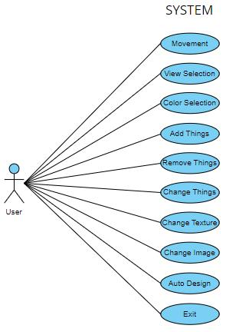

Use Case Model

## Scope and Modules System

**5.1 Scope**

The scope of the Home Interior Design Simulator encompasses various aspects of interior design planning. It includes the ability to customize room, modify colors, add or remove things, and adjust furniture placement. Users can select and apply different materials, textures, colors, and finishes to walls, furniture, and other elements. The simulator also allows for the simulation of different views conditions and provides virtual walkthroughs for users to experience their designed spaces. The scope extends to ensuring a user-friendly interface, performance optimization, compatibility with virtual reality hardware devices, and the incorporation of security measures to protect user data.

**5.2 Modules involved**

The Home Interior Design Simulator in VR comprises several interconnected modules to facilitate the design and visualization process. These modules may include:

**Player Movement:** This module is helpful for player movement. There are Arrow keys of keyboard is used for player movement. Up arrow is useful for forward movement, left right arrow for left right movement and down arrow for backward movement.

**Room Customization**: This module allows users to customize room by changing its wall and roof colors, add or remove things and changing things .

**Adding Object :** This module enables users to select and add furniture items, decor objects, and other elements within the virtual rooms. User can add all things by interactable UI button.

**Removing Object :** This module enables users to select and remove furniture items, decor objects, and other elements within the virtual rooms. User can add all things by interactable UI button.

**Material and Texture Selection:** This module provides options for users to choose and apply various materials, textures, colors, and finishes to different surfaces. User can change all things by interactable UI button.

**Image Selection:** This module provides options for users to choose and apply images from given list. User can change all image by interactable UI button.

**Virtual Walkthrough:** This module enables users to take virtual tours and walkthroughs of their designed spaces, gaining a better understanding of the spatial layout and overall ambiance.

**User Interface and Interaction:** This module focuses on the design and development of a user-friendly interface, intuitive controls, and seamless interaction with the simulator.

**Performance Optimization:** This module ensures the simulator performs efficiently and provides a smooth and responsive user experience, considering rendering speed, optimization techniques, and resource management.

## REQUIREMENTS

**6.1 Hardware Requirements:**

The Home Interior Design Simulator in VR requires the following hardware components:

**Virtual Reality Headset:** A compatible virtual reality headset is necessary to provide an immersive 3D experience. Examples include Oculus Rift, HTC Vive, or Windows Mixed Reality headsets.

**Computer System**: The computer system should meet the minimum specifications required for running the virtual reality software smoothly. This typically includes a powerful processor, sufficient RAM, a dedicated graphics card, and ample storage space.

**Input Devices:** Input devices such as controllers, motion sensors, or hand tracking devices may be required to interact with the virtual environment and manipulate objects within the simulator.

**Display Monitor:** Although the primary focus is on virtual reality, having a high-resolution display monitor can be beneficial for non-immersive interactions and accessing the software outside of virtual reality mode.

**6.2 Software Requirements:**

The Home Interior Design Simulator relies on the following software components:

**Operating System:** The simulator can be developed to run on different operating systems, such as Windows, macOS, or Linux, depending on the target platform.

**Virtual Reality Software Development Kit (SDK):** An SDK specific to the chosen virtual reality platform, such as Oculus SDK, SteamVR SDK, or Unity XR, is required to develop and integrate virtual reality features into the simulator.

**3D Modeling and Rendering Software:** Software tools like Autodesk 3ds Max, Blender, or SketchUp can be used for creating and rendering 3D models of furniture, objects, and architectural elements.

**Programming Languages and Frameworks**: Programming languages such as C#, , along with frameworks like Unity can be utilized for the development of the simulator.

**7 Screenshots | User manual**

This section provides screenshots of the Home Interior Design Simulator to showcase its visual interface, features, and functionalities. Alongside the screenshots, a user manual can be included, which provides step-by-step instructions on how to use the simulator effectively. The user manual should cover topics such as user registration, room customization, furniture placement, material selection, lighting simulation, and virtual walkthroughs.

1. **Simulator Start Scene**

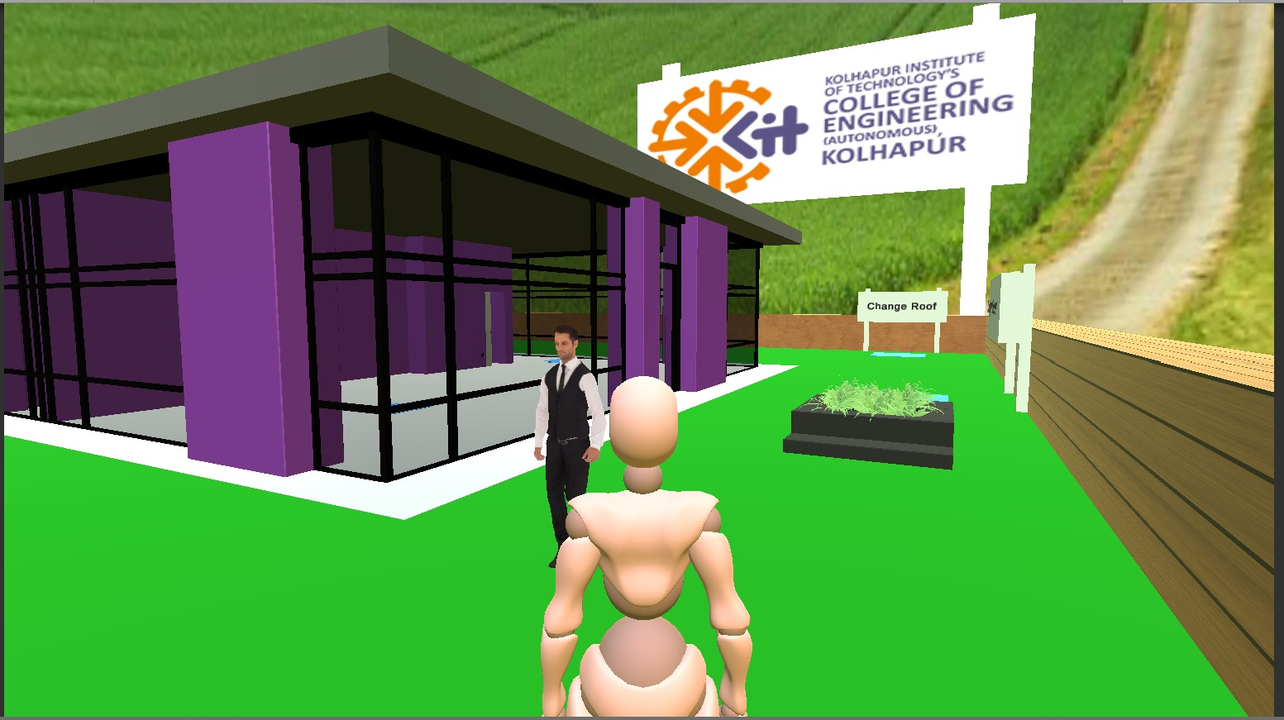

The Simulator can open by clicking on exe file. After loading simulator above scene will be appear.

For player interaction you need to press arrow keys of keyboard.

1. **Simulator Select Color Scene-**

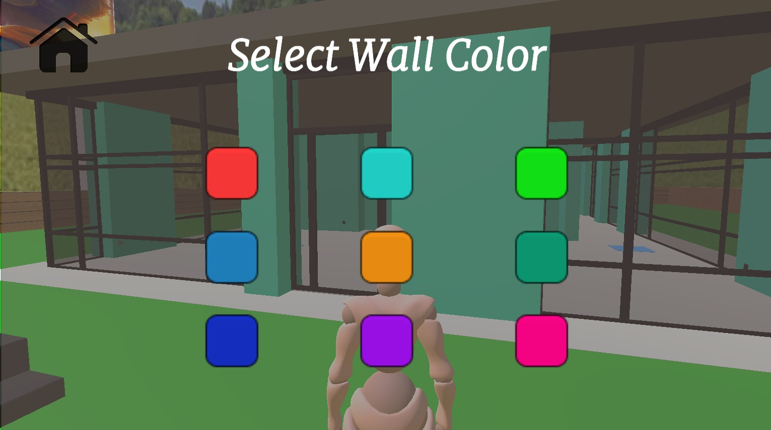

When player inters in wall color trigger box then select wall color UI panel will be appear.

There are total 9 colors from which you can change the wall color.

1. **Simulator Select Function Scene-**

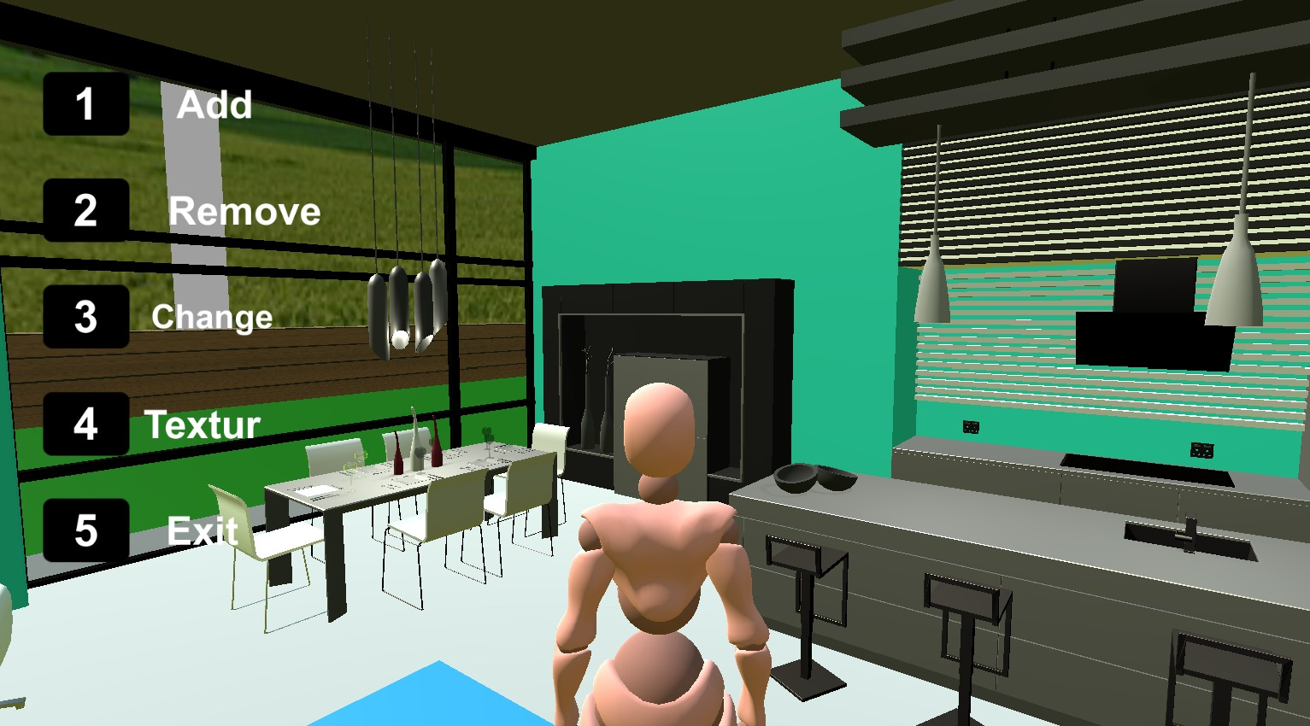

When Player Enters in Select function Block then select function UI is appear. There are 5 Buttons in scene which are add, remove, change, texture. When user click on button then new function panel will be appear.

1. **Simulator Select Texture Scene**-

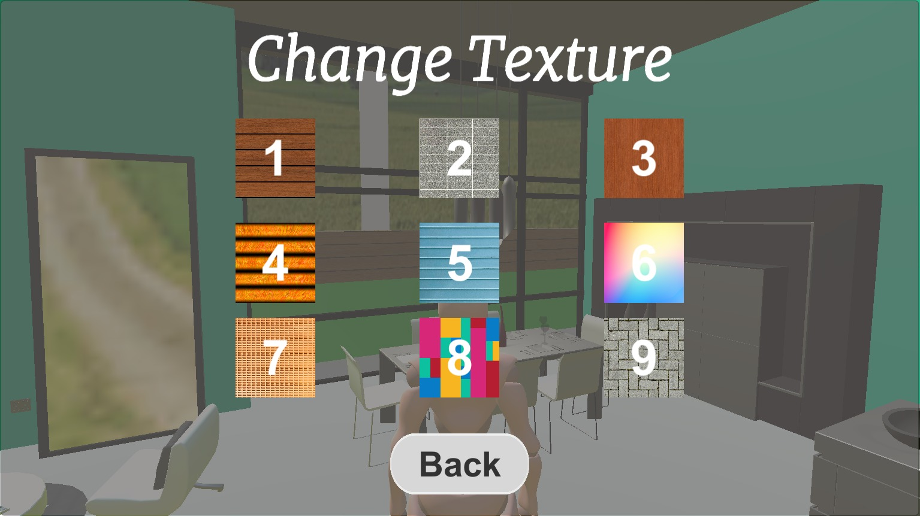

When player inters in wall Texture Button then select texture UI panel will be appear.

There are total 9 texture from which you can change the object texture.

1. **Simulator Change Image Scene-**

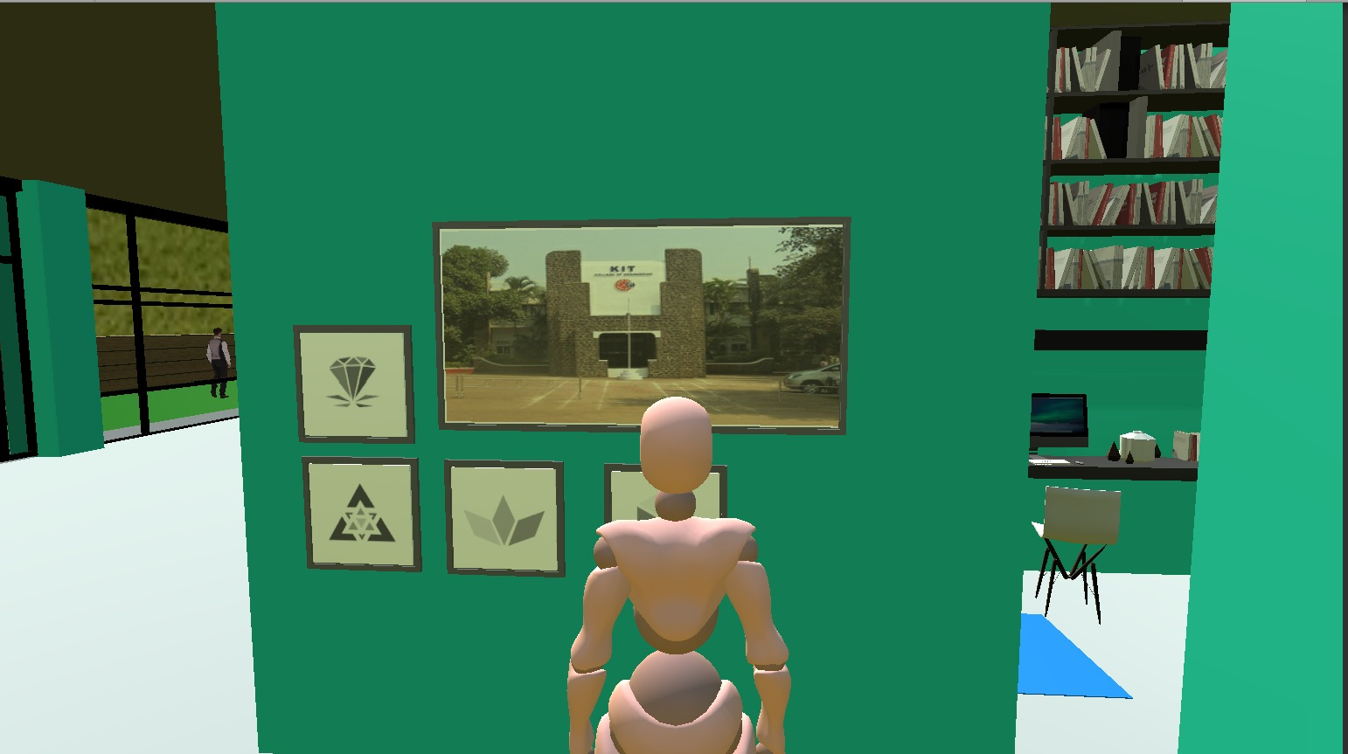

When Player Enters in near image then change image UI is appear. There are 3 images in scene which are use to change the image. After changing the image the image is added to scene,

1. **Simulator Change Image Scene-**

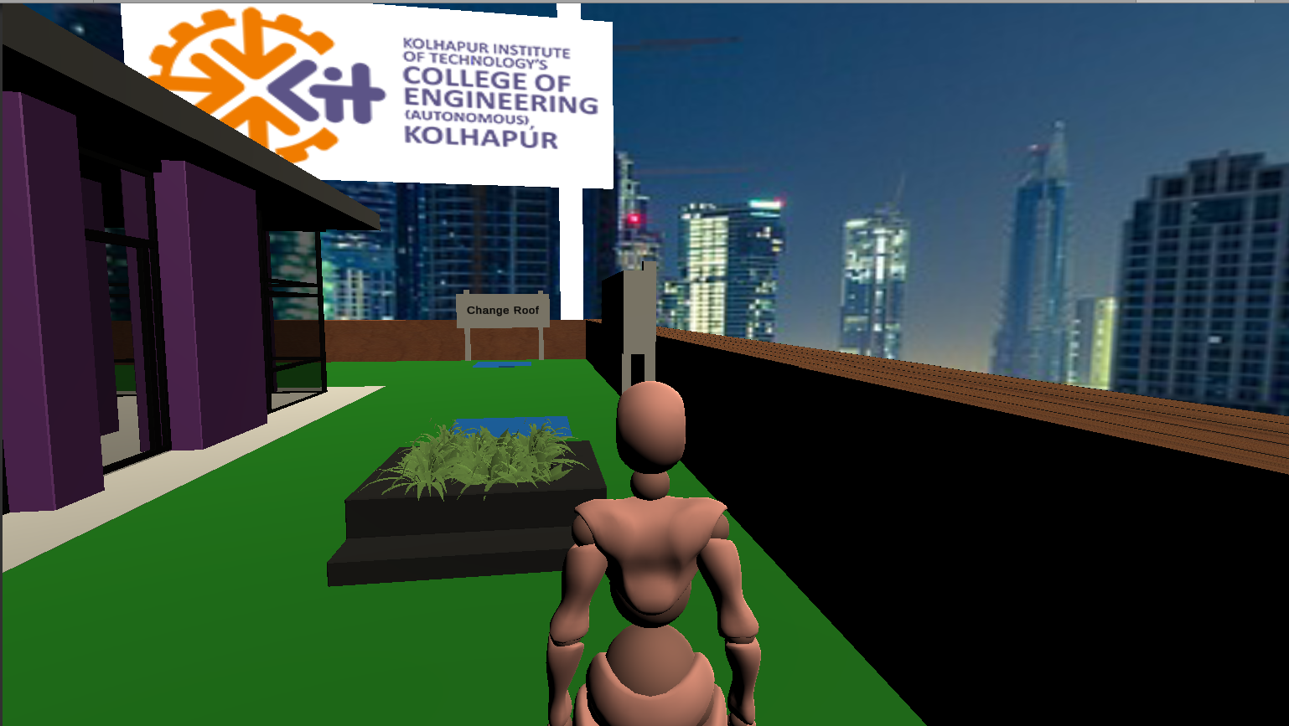

When Player Enters in Select View Block then select View UI is appear. There are 3 view in scene which are day, city night and ocean. When user click on button then view will be change.

1. **Simulator Advertising Banners**

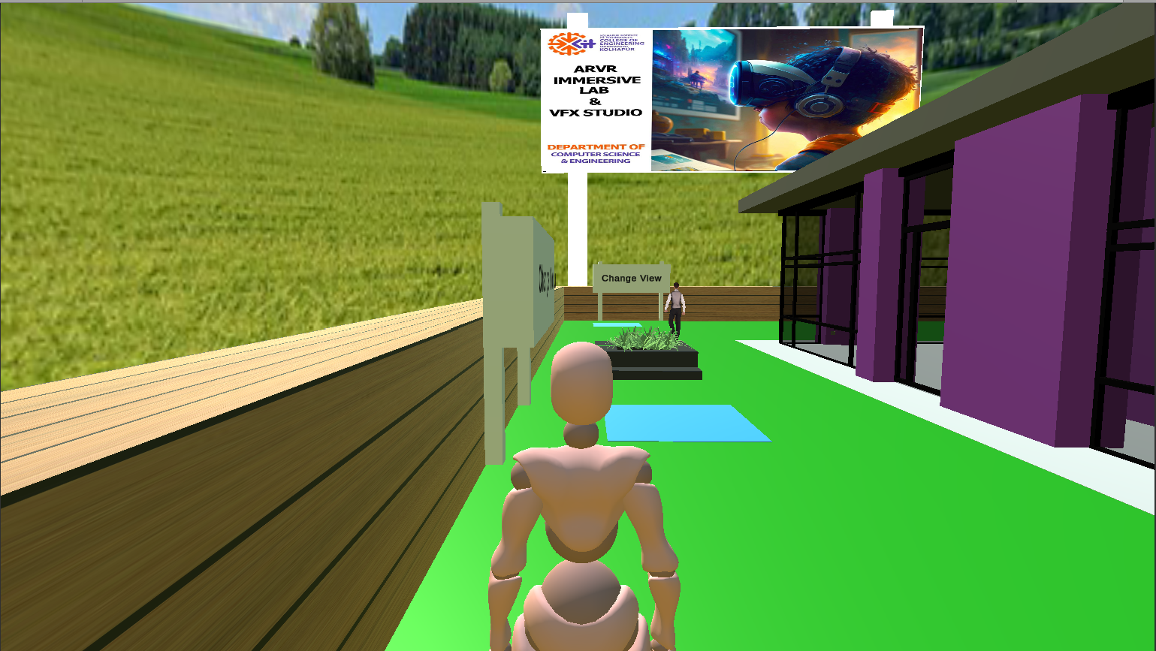

There are various Advertising banners which will be used for Advertising.

## PROJECT MANAGEMENT

## Process Model

The process model selected for the development of the Home Interior Design Simulator is an iterative and incremental model. This model allows for flexibility and adaptability during the project lifecycle, enabling continuous improvement and feedback incorporation. The development process involves multiple iterations, each consisting of requirements gathering, design, implementation, testing, and evaluation. This iterative approach ensures that the project evolves gradually, with regular reviews and feedback sessions to refine and enhance the simulator's features and functionalities. By employing an iterative and incremental model, the development team can address any issues or modifications efficiently and deliver a high-quality product.

## Feasibility study

A feasibility study was conducted to assess the viability and potential success of the Home Interior Design Simulator project. The study included the following aspects:

Technical Feasibility: The technical feasibility of the project was evaluated by assessing the availability and compatibility of the required hardware and software components. This involved considering the capabilities of virtual reality headsets, computer systems, and the software development tools needed for the project.

Economic Feasibility: The economic feasibility analysis involved estimating the project's costs, including hardware and software expenses, development resources, and ongoing maintenance costs. Additionally, potential revenue streams, such as licensing fees or subscription models, were evaluated to determine the project's financial viability.

Operational Feasibility: The operational feasibility analysis focused on evaluating the practicality and operational aspects of implementing and maintaining the simulator. This included considering the availability of skilled personnel, the required infrastructure, and any legal or regulatory considerations.

Schedule Feasibility: The schedule feasibility assessment involved estimating the project timeline and considering any dependencies or constraints that may impact the development process. This allowed for the identification of potential risks and the development of a realistic schedule for completing the project within the desired timeframe.

1. **CONCLUSION**

The Home Interior Design Simulator project has successfully achieved its objectives of providing users with an immersive and intuitive experience in visualizing and planning interior designs. By leveraging virtual reality technology, users can now explore and customize virtual spaces in a realistic 3D environment. The simulator enables users to customize room dimensions, place furniture items, experiment with different materials, and simulate lighting conditions. Through the development process, the team addressed challenges, incorporated feedback, and ensured the delivery of a high-quality product.

1. **REFERENCES**

1. Azuma, R.: A survey of augmented reality. Presence Teleoperators Virtual Environ. 6(4),355–385 (1997)

2. Bacca, J., Baldiris, S., Fabregat, R., Graf, S.: Augmented reality trends in education: asystematic review of research and applications. Educ. Technol. Soc. 17(4), 133–149 (2014)

3. Boletsis, C., McCallum, S.: The table mystery: an augmented reality collaborative game forchemistry education. In: Ma, M., Oliveira, M.F., Petersen, S., Hauge, J.B. (eds.) SGDA2013. LNCS, vol. 8101, pp. 86–95. Springer, Heidelberg (2013). doi:10.1007/978-3-642-40790-1_9

4. Bressler, D.M., Bodzin, A.M.: A mixed methods assessment of students’ﬂow experiencesduring a mobile augmented reality science game. J. Comput. Assist. Learn. 29(6), 505–517(2013)

5. Cascales, A., Laguna, I., Pérez López, D., Perona, P., Contero, M.: Augmented reality forpreschoolers: an experience around natural sciences educational contents, pp. 103–112(2012)8. Chen, C.M., T

* Project_GitHub_link- - https://github.com/vishwajitvp07/Home_Interior_Design_Simulator